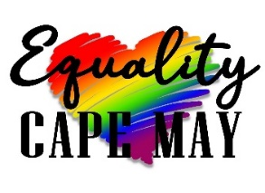

**ORGANIZATION PROFILE**

**Vision**: Cape May County is a safe**,** inclusive, equal and welcoming environment for all LGBTQIA+/Queer residents and visitors.

**Mission**: Equality Cape May’s mission is to build and strengthen Cape May County’s LGBTQIA+/Queer community and promote welcoming attitudes and equality through organization, advocacy and social connection.

**Values**

* Advocacy
* Visibility
* Community Building
* Inclusivity
* Education/Outreach

**Social Impact Statement**

At Equality Cape May, we are dedicated to building a vibrant and inclusive LGBTQIA+/Queer community in Cape May County. Through our mission, we foster a welcoming and equal environment by organizing diverse social events, advocating for change and enhancing visibility.

We host monthly social events, ranging from bowling and nature walks to trivia nights, which encourage fellowship and reduce isolation. These gatherings are attended by hundreds of community members throughout the year and are offered at little to no cost, ensuring accessibility for all. Our Pride events in June, including a kickoff party and our flagship Pride march, bring together hundreds of people to celebrate, learn and connect.

In addition to social connection, we prioritize visibility and advocacy. Our participation in the West Cape May Christmas Parade and initiatives like hiring a banner plane with supportive messages highlight our commitment to making the LGBTQIA+/Queer community seen and heard. Our advocacy committee actively monitors local, state and national issues, mobilizing our community to stay informed and take meaningful action.

We also support the future of our community by offering annual scholarships to LGBTQIA+ youth pursuing higher education. By investing in their education, we help empower the next generation of leaders and advocates.

With 100% of our proceeds supporting these programs, we ensure that every contribution directly impacts the community. At Equality Cape May, we believe in the power of advocacy, visibility, and connection to create lasting change and a more inclusive future for all.